RMA (RETURN MERCHANDISE AUTHORIZATION) FORM

Send this document together with the goods to:  ULTRAFLEX CONTROL SYSTEMS SRL  Via XXV Aprile, 45 – 16012 Busalla GE - Italy | Filling by UCS - Ultraflex Control Systems srl  RMA Nr:

Company:

Project:

Date:
Window were actuator is  installed: |  | Top  hinged | Bottom  hinged | Side  hinged | Parallel | Roof
 |  | 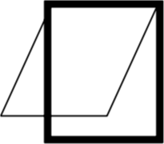 | 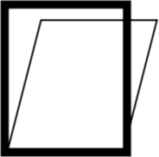 | 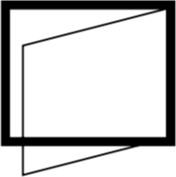 | 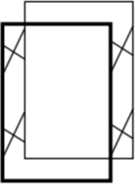 | 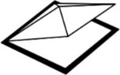
Open Inwards: |  | ☐ | ☐ | ☐
Open Outwards: |  | ☐ | ☐ | ☐ | ☐ | ☐

Quantity [pcs]:

Height [mm]:

Width [mm]:

Weight [kg]:

Inclination from vertical [°]:

Opening angle:

Application: | SMOKE VENT | NATURAL VENT | BOTH
 | ☐ | ☐ | ☐

Operated by: | BMS | LOCAL PUSH BUTTON | RADIO REMOTE CONTR. | SMOKE VENT  CONTR. PANEL
 | ☐ | ☐ | ☐ | ☐

Item Number: click here to type the text..
Serial Number (SN) of the product to be returned: click here to type the text.
Detailed Description of the failure: click here to type the text.

In case of failure, it happened:
☐ Just after electrical connection
☐ During first operation
☐ During first operation at the opening position
☐ After few cycles
☐ After years of operation. Specify the number of years: click here to type the text.

☐ After months of operation. Specify the number of months: click here to type the text.

☐ Other: click here to type the text.

If case of actuator connected in group, did the others fail? ☐Yes ☐No ☐Some

Evidence of damages on the actuator: ☐Chain ☐Spindle☐ Brackets ☐Terminal of chain/spindle ☐Other

Signs of corrosion? ☐Yes ☐ No

Signs of overheated wires or terminals (Melted, burnt, discolored)? ☐Yes ☐No

Pictures of product and installation:


- Goods sent without RMA Nr. or with charges to the receiver will be refused. Send this form fulfilled to UCS to receive your RMA nr.
- The RMA Nr. is valid 30 days from issue date.
- All fields of this form are mandatory. In case of missing or wrong data, a new form will be requested.
- A detailed description of the claim is required (generic claims as “doesn’t work” are not accepted).
- In case there are several products to be returned, one form for each product is required.
- In case of replacement or reparation covered by Warranty (ref. Warranty Conditions on UCS website or catalogue), costs for reparation (or replacement) and return shipment to che Company will be carried out by UCS.
- UCS will proceed on reparation as soon as possible.
- In case of replacement or reparation not covered by Warranty (ref. Warranty Conditions on UCS website or catalogue), costs for reparation (or replacement) and return shipment to che Company will be carried out by the Company (in advance).
- In case products are found not covered by Warranty, UCS will provide a quotation for their reparation; the Company needs to accept it within 30 days, otherwise UCS will scrap the returned products and charge the Company with € 20,00 for the analysis of the failure.

Place and date________________________________________ Signature______________________________________________

SEND THE FORM TO UCS PER EMAIL OR FAX: ucs@ultraflexgroup.it - FAX +39 010 9620333
WAIT FOR THE RETURN MERCHANDISE AUTHORIZATION (RMA) BEFORE SENDING THE GOODS

